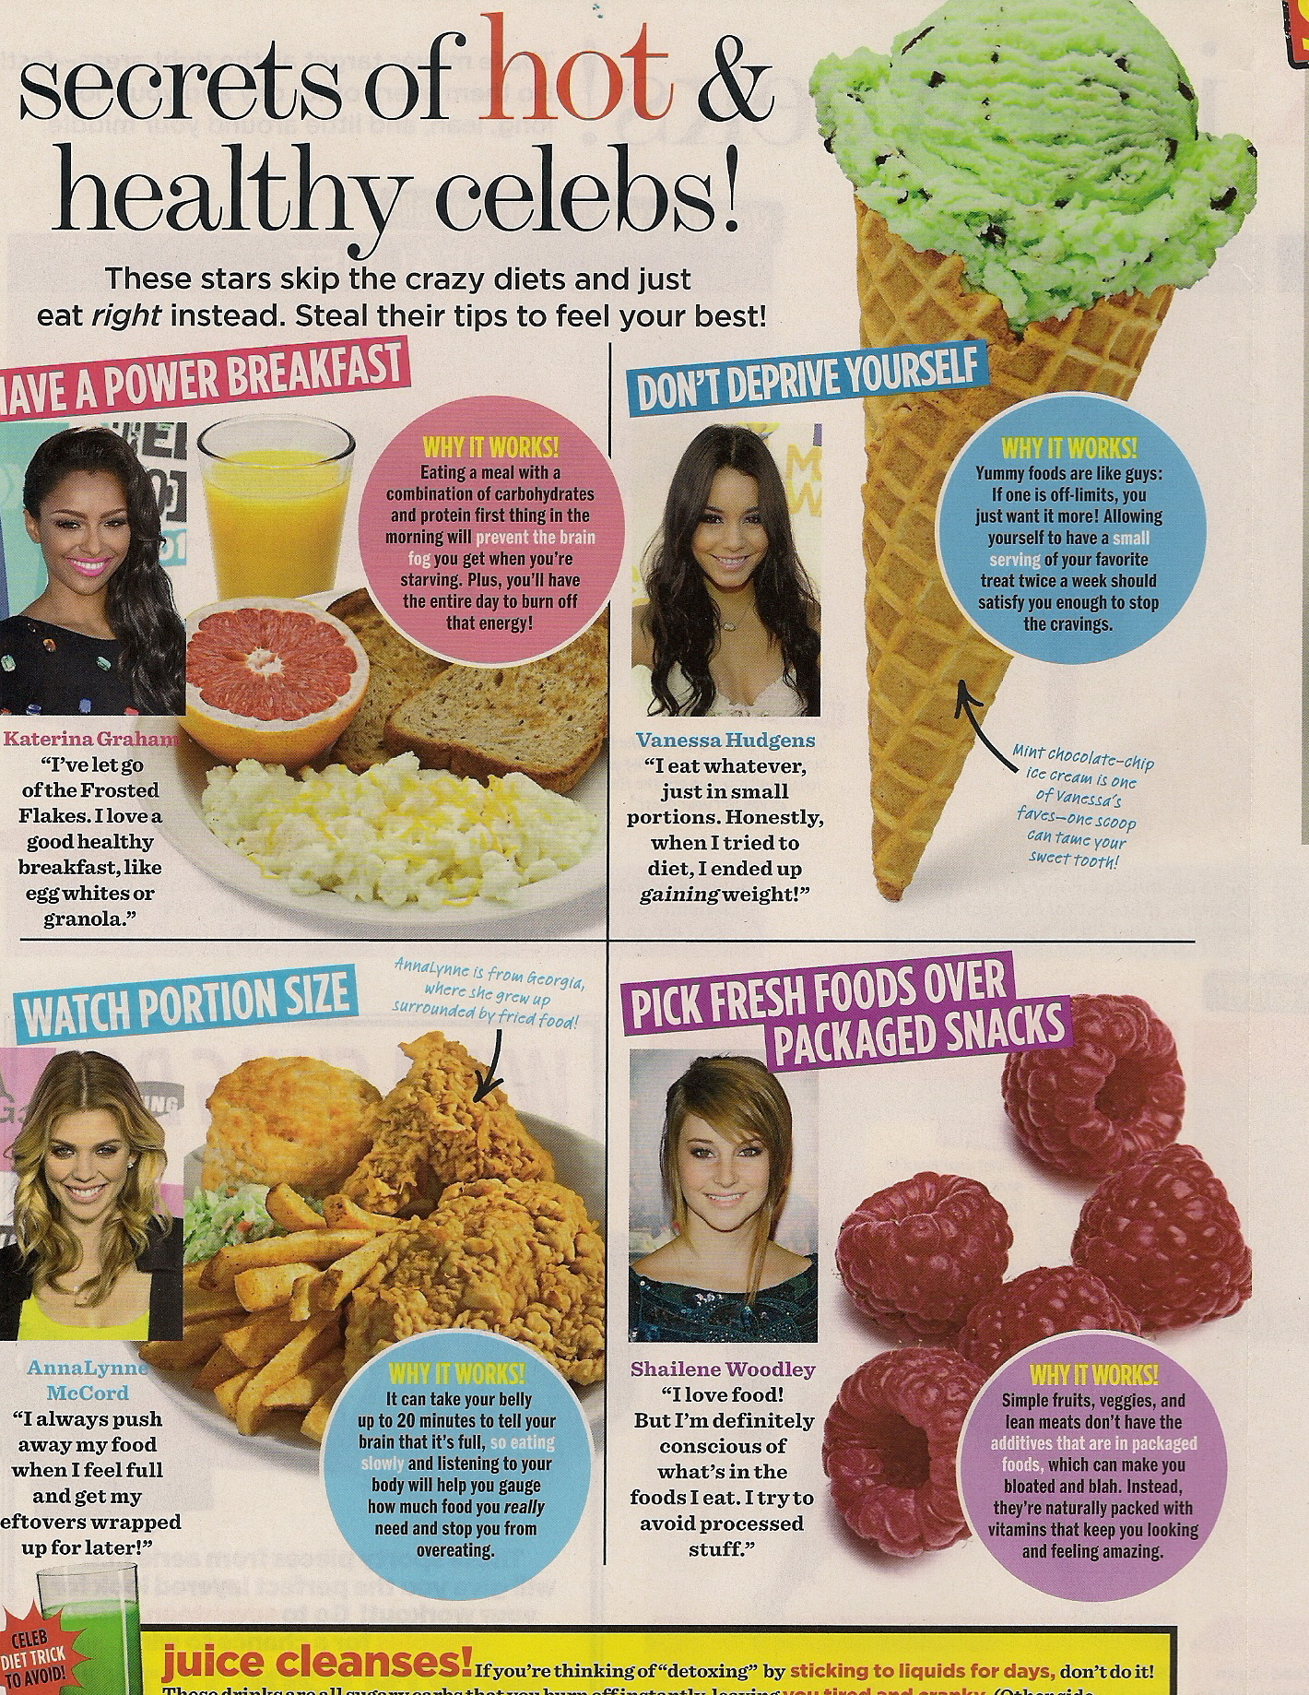

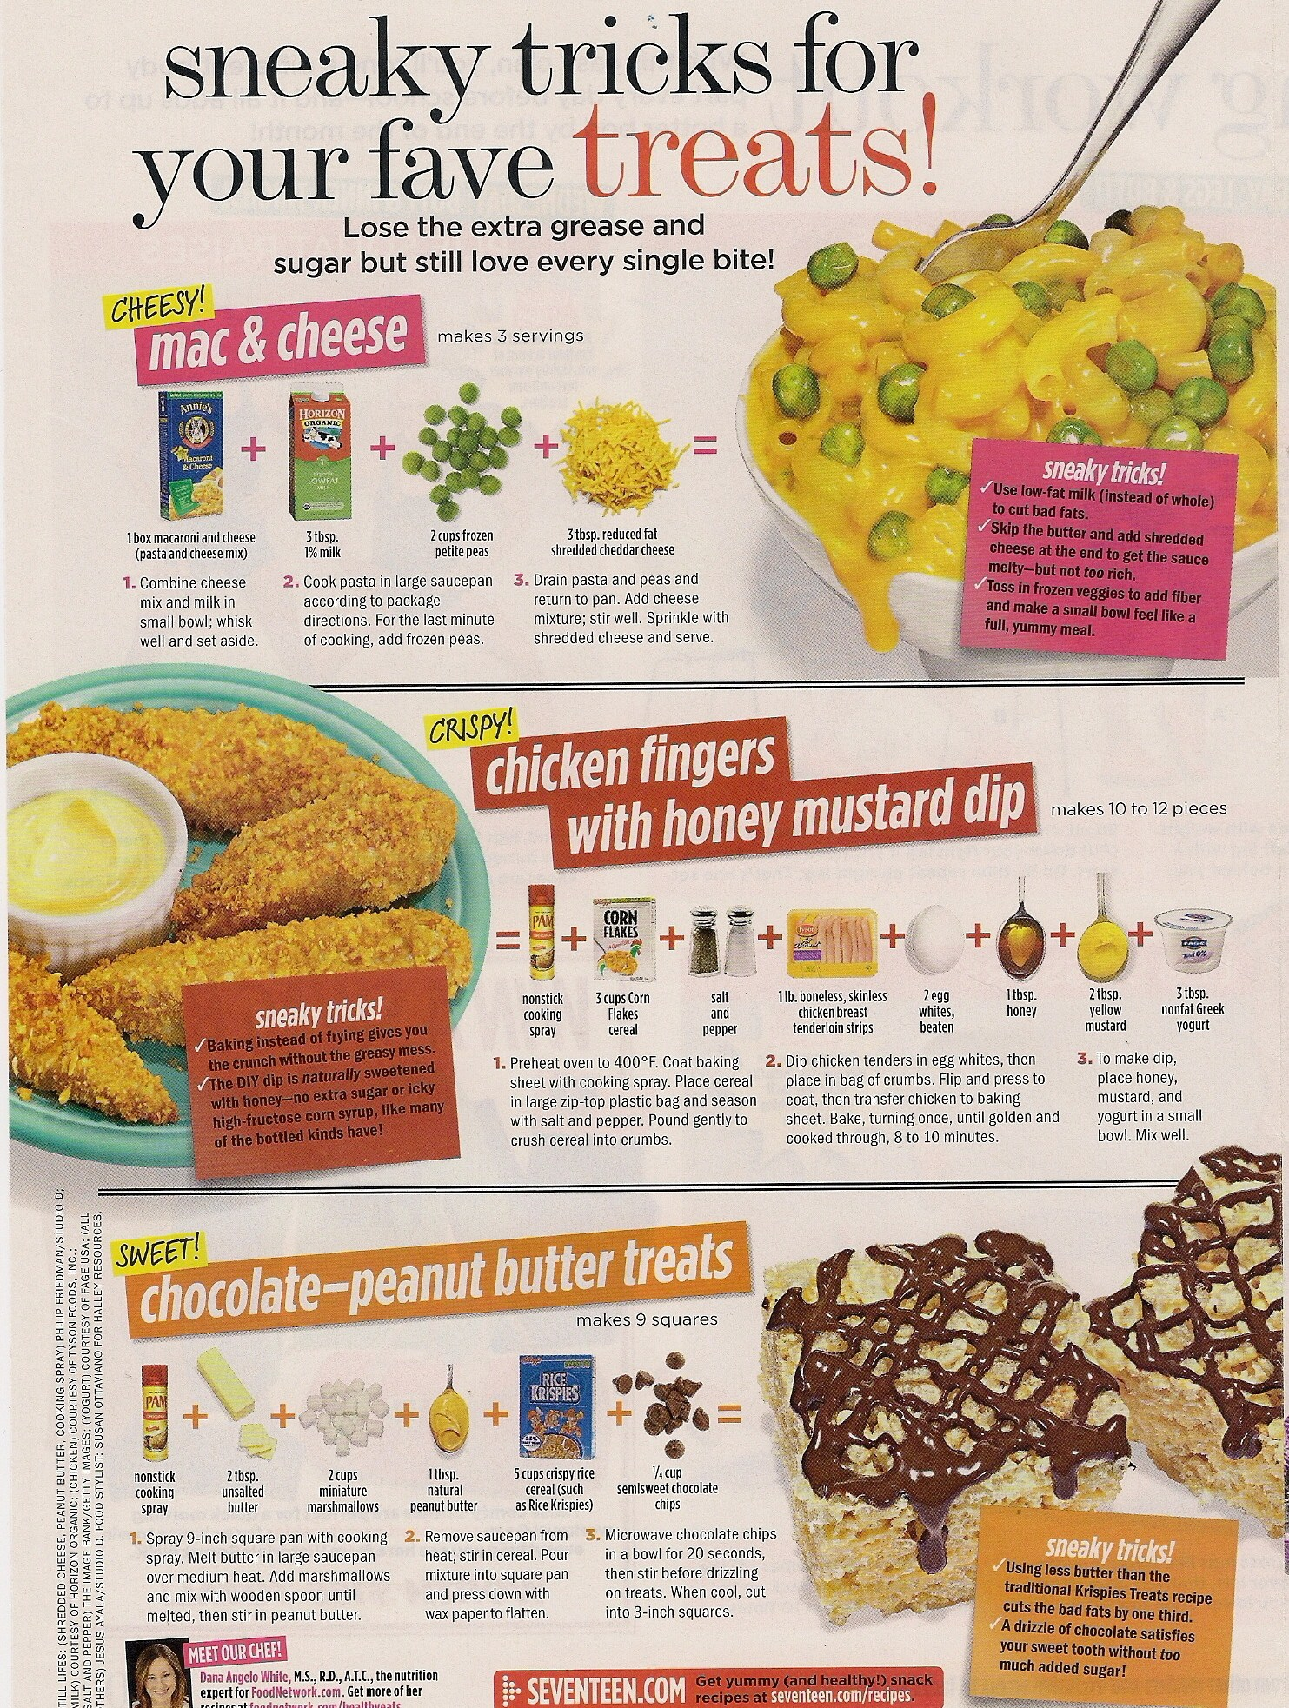
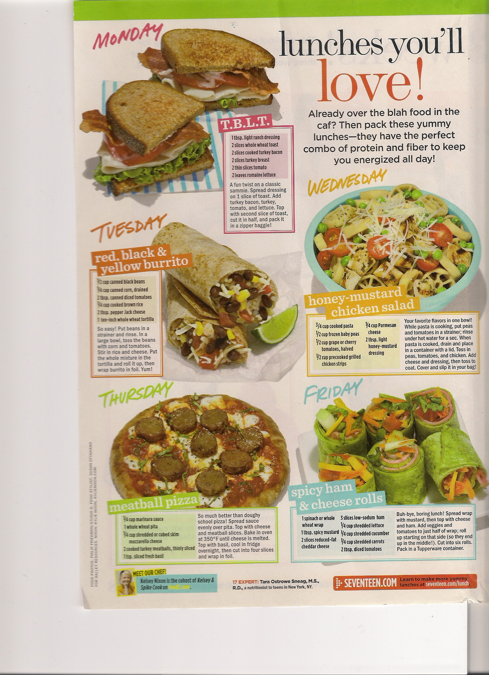
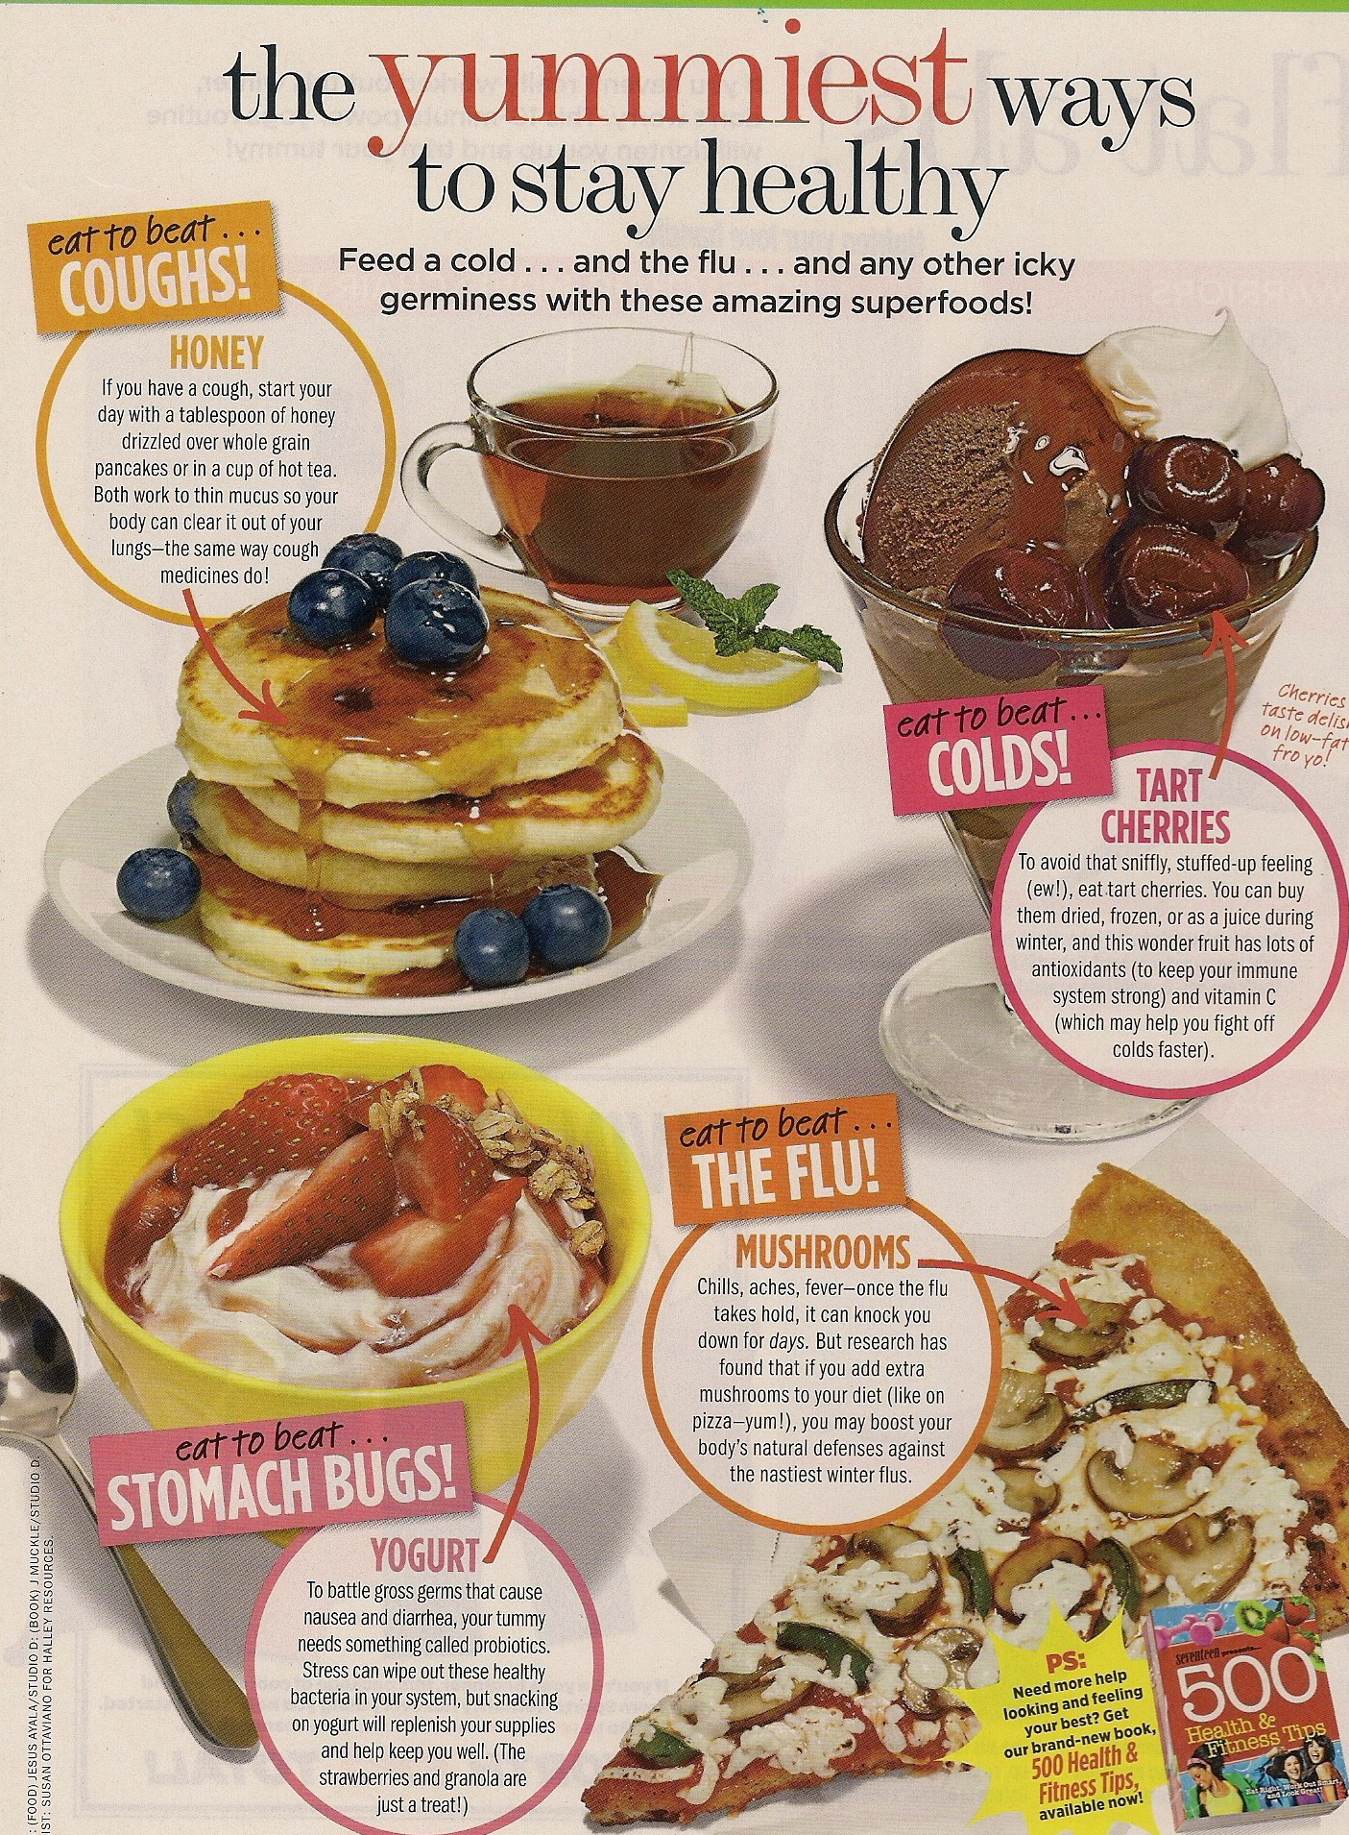

Body Chart

This is a BMI (Body Mass Index). This should give you an idea of where you should be in your weight.
*Example: I am 5’4” and around 135 pounds. So my BMI is 24% which means that I have 24% body fat…. That is a normal percent
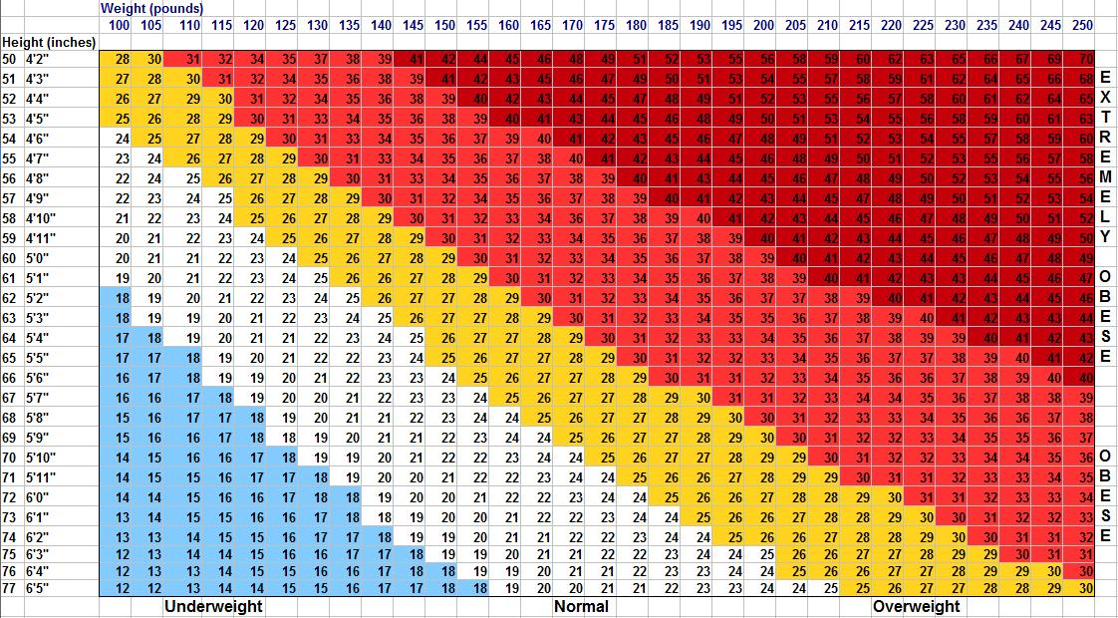
BLUE= underweight
White= Normal
Yellow= Overweight
Red= Obese
Dark red=
Extremely
Obese.

Diet Plan

Miami Heart Institute
3 Day diet
Must Be Followed Exactly I Lose 10 Ibs. in 3 days FIRST DAY:
Breakfast; black coffee or tea, ½ grapefruit, 1 slice of toast, 2 tbs. peanut butter. Lunch: ½ up tuna, 1 slice toast coffee or tea.
Dinner: 2 slices any type of meat (about 3 ozs.) 1cup string beans, 1 beets, 1 small apple, 1 cup vanilla ice cream.
Day 2:
Breakfast: 1 egg, ½ banana, 1 slice toast, black coffee or tea Lunch: 1 cup cottage cheese, 5saltine crackers.
Dinner: 2 hotdogs, 1 cup broccoli,1/2 cup carrots, 1/2 banana, 1/2 cup pf vanilla icecream.
DAY 3:
Breakfast: 5 saltine crackers, 1 slice cheddar cheese, 1 small apple, black coffee or tea. Lunch: 1 hard boiled egg, 1 slice toast.
Dinner: 1 cup tuna< 1 cup beets,1 cup cauliflower, 1/2 cantaloupe, 1/2 cup vanilla ice cream.
Diet works on chemical breakdown and is proven. Do not vary or substitute any of the above foods. Salt and pepper may be used. No other seasonings. Where no quantity is given there are no restrictions. Other than common sense, this is to be used 3 days at a time.
In three days you will lose 10 Ibs., after 3 days of dieting you can eat normal food, BUT do not overdo it. After your 4 days of normal eating, start back on your 3 day diet. You can lose up to 40 Ibs. in a month, if you stick to it. (for some people only)

*This is another diet
General Instructions
1. Do not skip meals 2. Do not eat between meals 3. Eat only the amount of food indicated on diet 4. Use salt sparingly 5. Do not fry foods 6. Prepare fruits without sugar 7. Do not use alcoholic beverages 8. A serving equals one half measuring cup
Breakfast
1 serving of 10% fruit
1 poached or soft boiled egg
1/2 slice white, rye or whole wheat bread or toast without butter or jelly Coffee or tea without cream or sugar
Lunch
1 1/2 ounces of lean beef, pork, lamb, veal, chicken, turkey or fish 2 servings of 3% vegetables either raw, cooked or in a salad
1 small serving of 15% fruit o' 1 serving of 10% fruit
_1 glass of fat free milk.
Dinner
1 cup of clear vegetable soup, broth or bouillon
2Yz ounces of lean beef, pork, lamb, veal, chicken, turkey or fish 1 small serving of 6% vegetable
1 serving of 3% vegetable either raw, cooked or in a salad 1 small serving of 15% or 20% fruit
1 glass of fat free milk
Coffee or tea without cream or sugar

3% VEGETABLES Asparagus
Beet greens Broccoli
Cabbage Cauliflower
Celery
Cucumber
Endive
Eggplant
Green pepper Lettuce Mushrooms
Okra
Radishes Sauerkraut Spinach
. Tomato

6% VEGETABLES Beets
Brussels sprouts Carrots
Green beans Kohlrabi
Onion
Pumpkin Rutabaga Squash
Turnip
5% FRUITS Cantaloupe Honeydew Rhubarb Strawberries Watermelon
15% VEGETABLES Artichokes
Green peas
Parsnips
10% FRUITS Apricots Blackberries Cranberries Currants Grapefruit Grapefruit juice Lemons
Limes
Oranges
Orange juice
Peaches '
Plums
20% VEGETABLES Corn
Dried beans Dried peas Lima beans White potato
15% FRUITS Apples Blueberries Cherries Grapes Kumquats Loganberries Pears' Pineapple Pineapple juice Raspberries
25% VEGETABLES Sweet potatoes Yams
20% FRUITS Bananas Grape juice Fresh prunes

